Writing Sample: Cyberbullying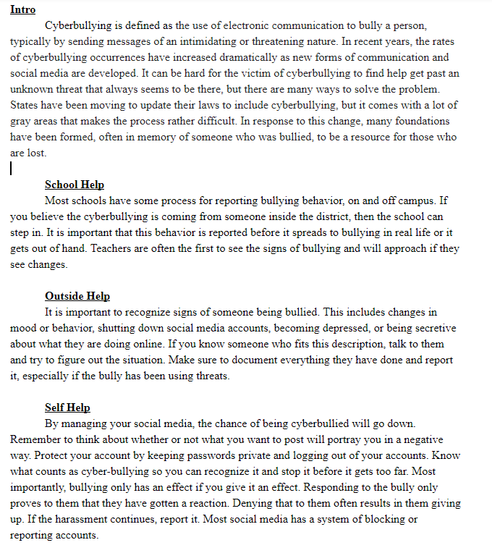

This sample includes several paragraph drafts that were used in a class website project on digital ethics. I wrote an introduction to cyberbullying and ways people can find help should they become victims of cyberbullying. While this assignment does not have the professional structure of a typical essay, the paragraphs I wrote still hold some good examples of writing informative pieces. This sample showcases my ability to relay information to a wide audience.